**Phase 93**

Now click on upload button

If all the thing gpoes right way then we can see all our product

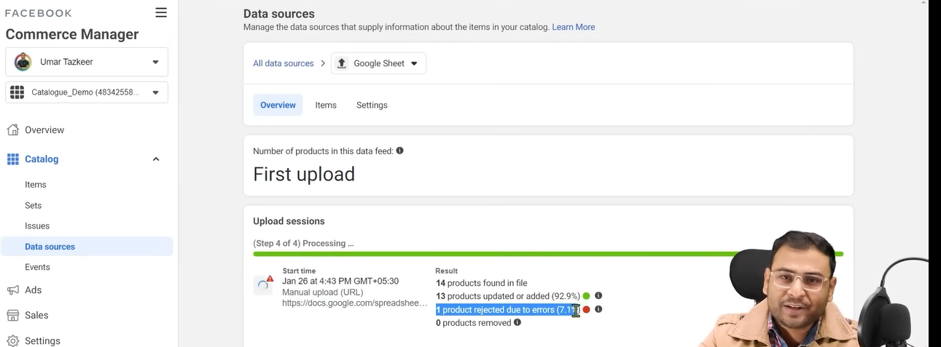

Now you can see that it is telling thw numberof product that gets accepted and number who got rejected

To see all the result

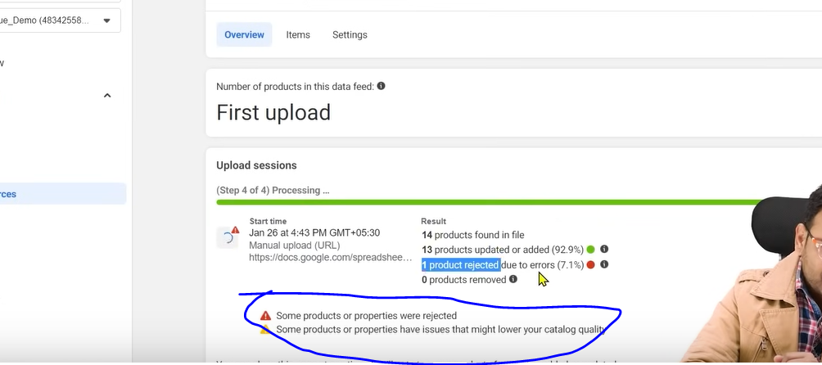

Click on the bove marked area

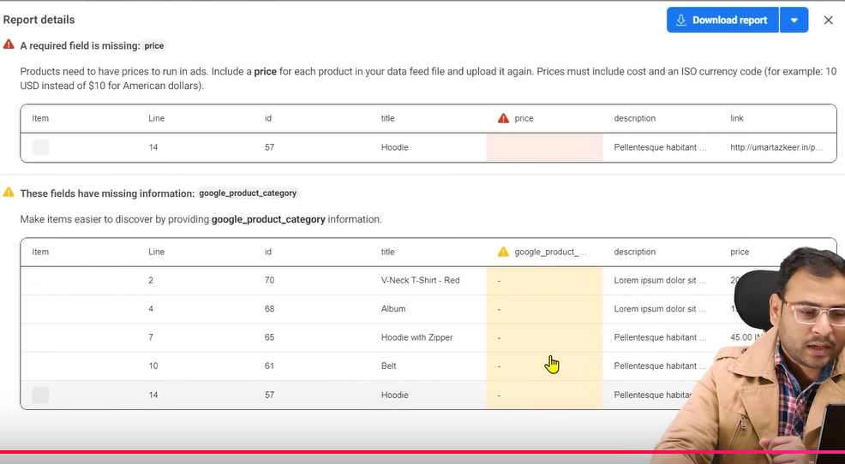

Here you can see the details of your error in Report details

It will tell you why tatproduct I getting that errors

In above it is showing that in line 14 there is no price mentioned of the product

Every product category have a specific code for Clothes and acceesseries we have 529 code

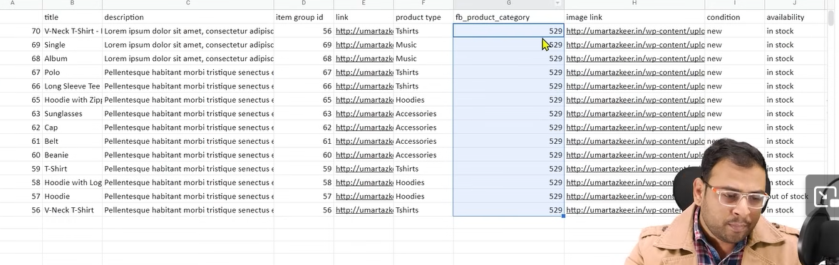

Instead of code you can write name also

I facebook ad understand that what category your product your ad are in and then ut will understand that what type of people your ad should be shown

That’s how we create our feed

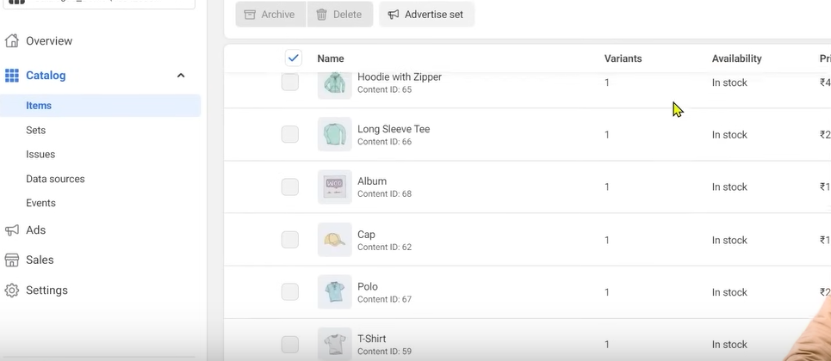

Now if you come to Catalog>Items then items list be shown as shown above

Now if we want to run catalog ads then we can do so

So this is needed to run catalog ads

Lesson 69:-

In this lesson we will learn about **Concept of product Set in FB Catalogues**

We are going to discuss ecommerce ads or catalog or our commerce manager

Whenever we run catalog ads then we need to understand that every product in our catalog are not for everybody measn we want to some of our product to other people and some to other people . It means we need to categories our product in our catalog or we need to form a product set

SO we will see what is product set and how we see it and why do we need it

People talk about Catlaog ads and hoew to optimize and create it but inside it there is sub part that is product set

It means on the basis of something let say parameter you define a group of product

NOw suppose there are 5 product and there prices are 100,200,300,400,500 etc and we categories by the way to choose product which has price more than or equal to 300 ruppess so three product will come inside this category

SO by this on the basis of different conditions to what to show our ad we do research . If we are showing the ad(product) to a group of people then what should be the ad(product) and on what fundamentals we need to create our product set what basis

Now whenever you open the Commerce Manager you see the intergface below

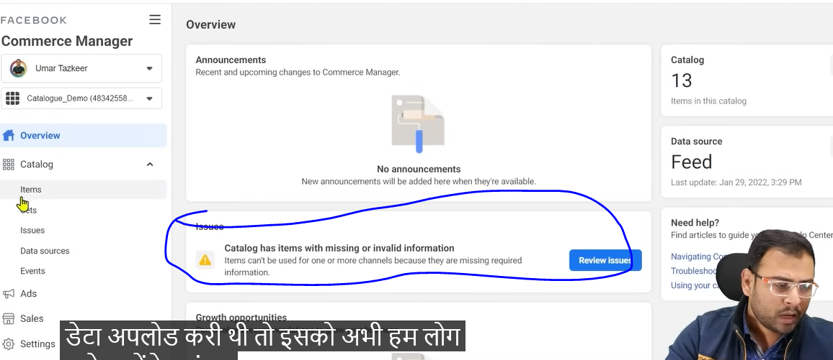

Ignore the marked one as we uploaded demo data.

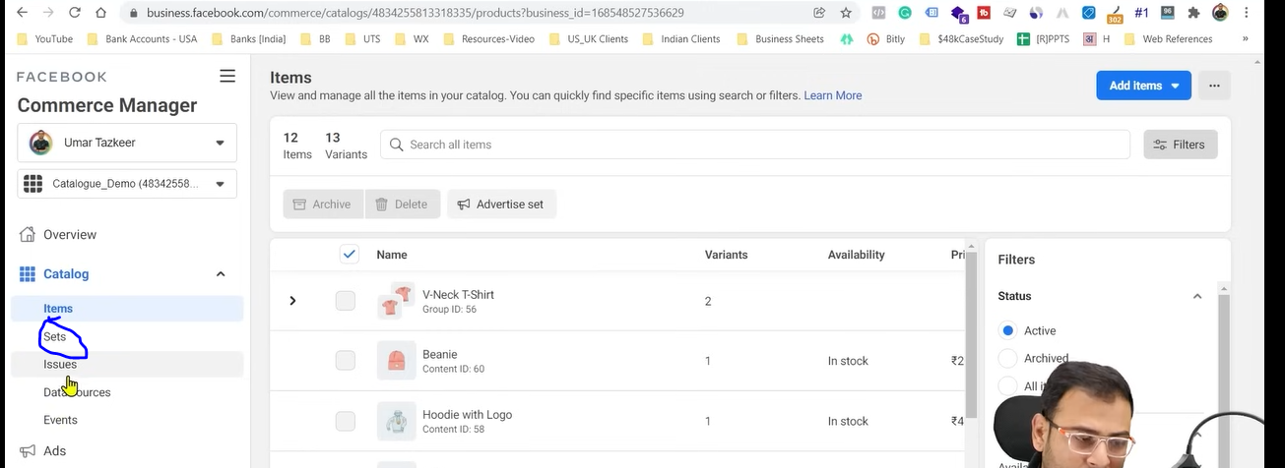

Now inside our catalog we have another menu that is set as marked above

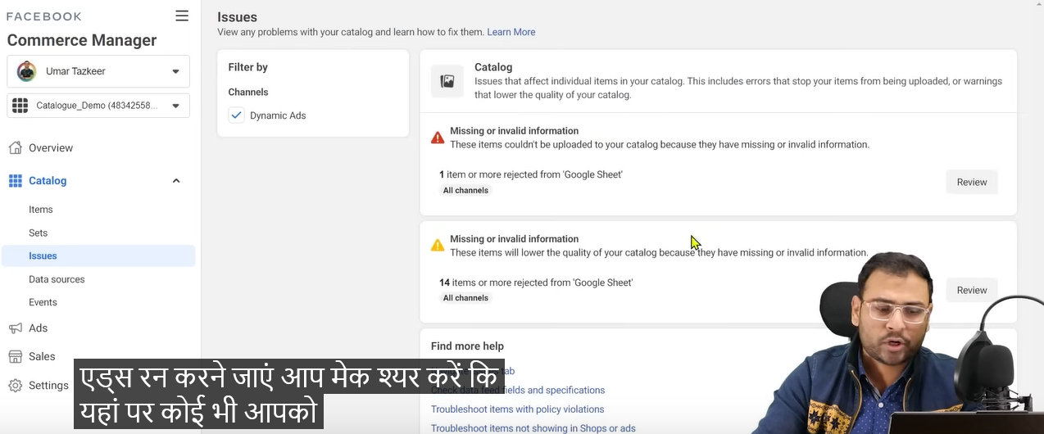

Whenver you run ecommere based ads or catalog ads then make sure there should be not issue shown in Issues tab in side menu

Resolve all those issues then create our set

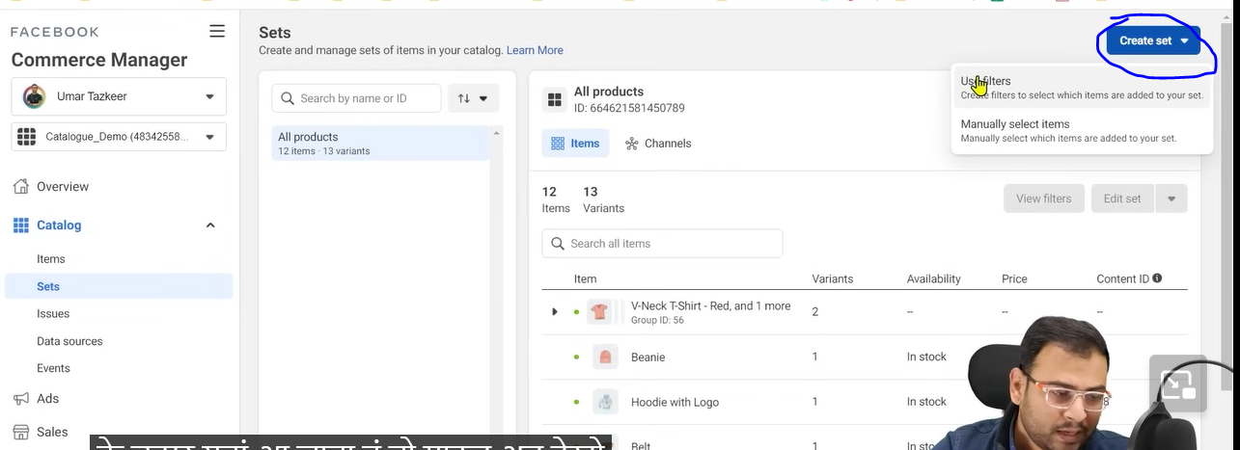

Now whenever you go to Catalog>Sets now go to marked button now a submenu will be opened

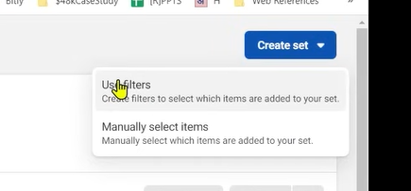

It shows two options first is use filter and another is Manually select items

In manually you choose manually according ton your comfort but in use filter you filter according to some condition like color, price, brand, on the basis of availability, sales price, variant etc. SO for examplkae we want to create set of those product who has price more then 5000 rupees.In such thing we use use filter

Suppose we want to filter oup people according to price of 3 rupees

SO when we click on use filter then

A mini panel will be open like this

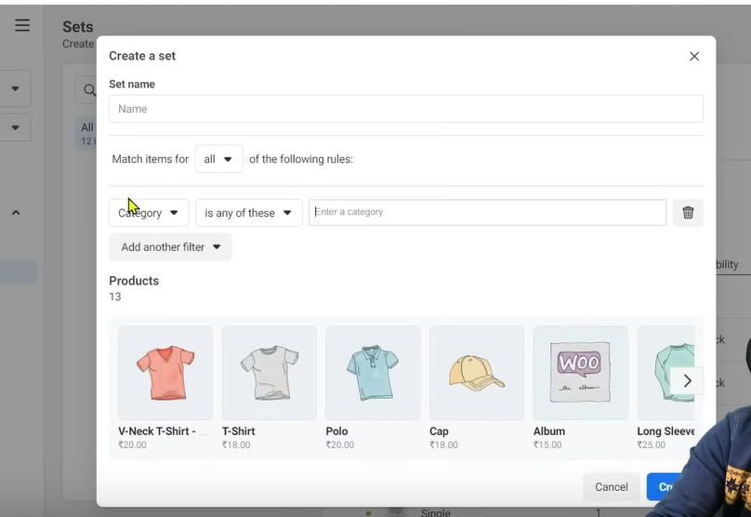

No when you click on category then a submenu will be opened

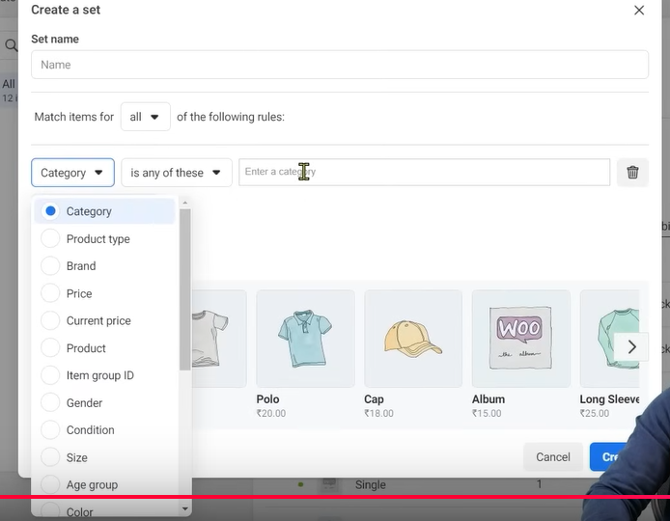

Choose the option according to whoc you want to filter AS you can see above you can set filter according to category,Product Type etc.

We choose product

And in next field choose greater then and then set the currency to INR

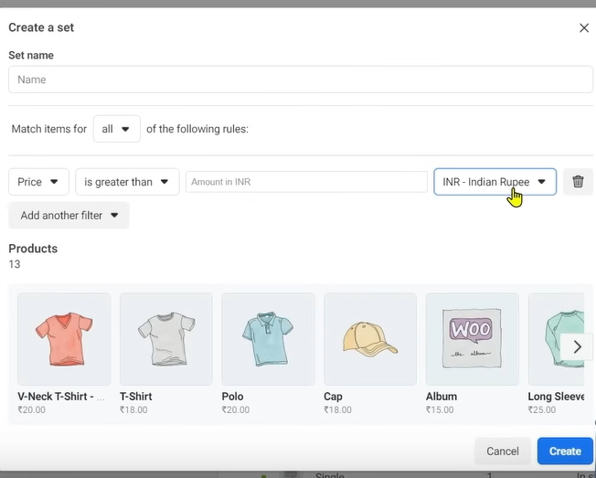

Now we enter the valur of 25 in the Amount in INR field then you can see there are only four product shown as shon below

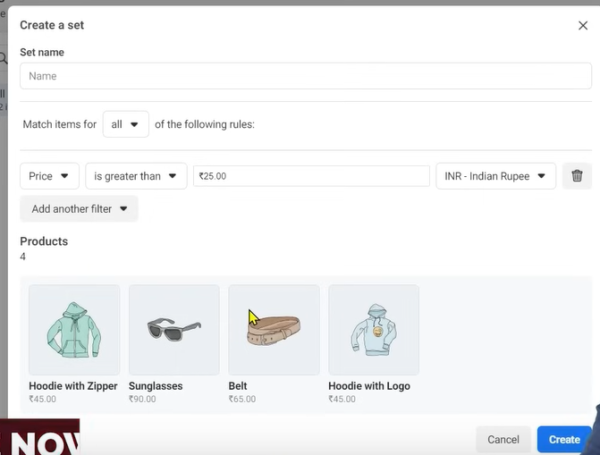

Sometimes you may feel that In your targeted audience you want ot target people who buy luxury brands.

It can happen that you want to show the ad to those audience that already purchased your products now you know there is some audience set who has bought a particular product

What could be the product similar to it

For example we are selling a remote and we know what type of people will buy a remote

When someone buy the remote then hey will surely buy some battery to run it so I will not show the ad of cell to all the people and I don’t have only cell as a product I have other products also measn in real time such scenerios happens when we say this our product set is for these particular people so to cater these situation we need product set

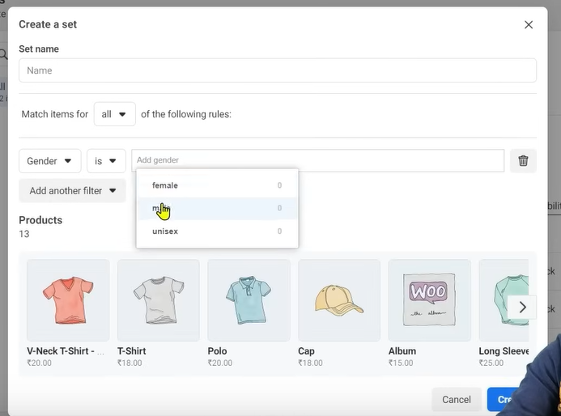

You can also filter according to Gender as shown above into Male, Female,Unisex.

Now you will filter it according to gender then it will not show any result why .This is because

Data that we want to filter we get from when we upload our product if we see details of any item in our catalog

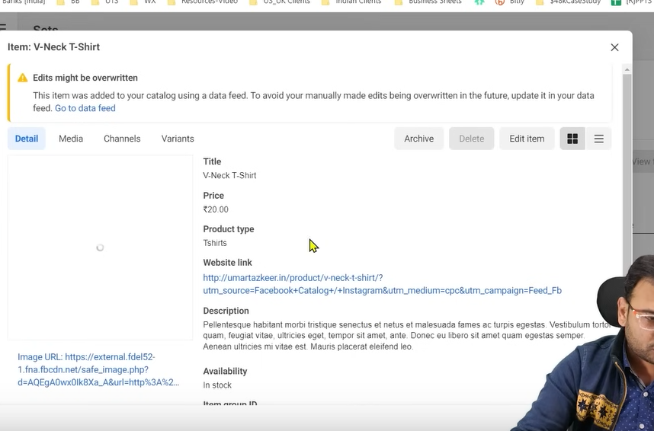

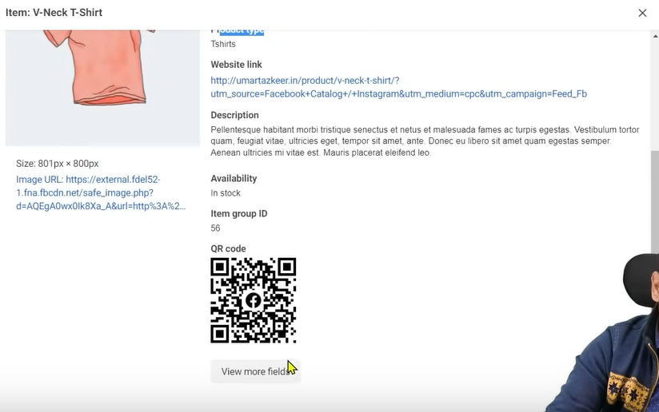

Now if you click on View more fields button then it will show mmore field

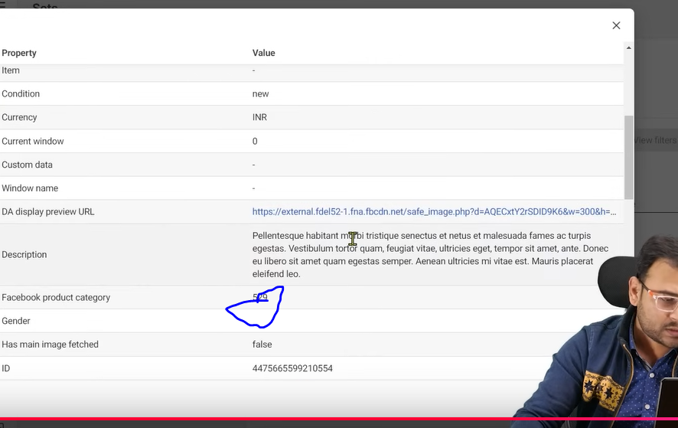

You can see no gender mentioned as marked above so ho can it filter your product

If we have mentioned the gender for which the product is made hten it would have shown in filter results

What we are saying is that how products are defined in the product feed it will give you scope on how much better you do filter

If we have already have that information that I will run male based ads or female based ads then your product feed should have that information

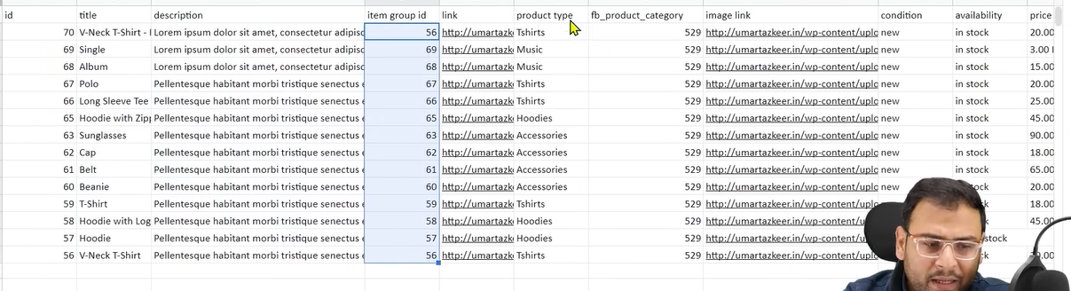

So in your product feed you can see many columns related to the different attrubutes of your product

Now you se in product type column you can see many types such as TShirts, Music, Accessories , Hoodies etc means if we want to run ad on the basis of product type then I can run ad on the basis of Hoodies, Tshirts etc.

Suppose if we choose product type tshirt means we want to advertise Tshirt product set.

**Phase 94**

For example if you have not even mentioned the proce in the feed then how you will filter it

Now if you go to filter and then you choose Product type then automaticslly list will be shown according to the type you added in the feed as marked below

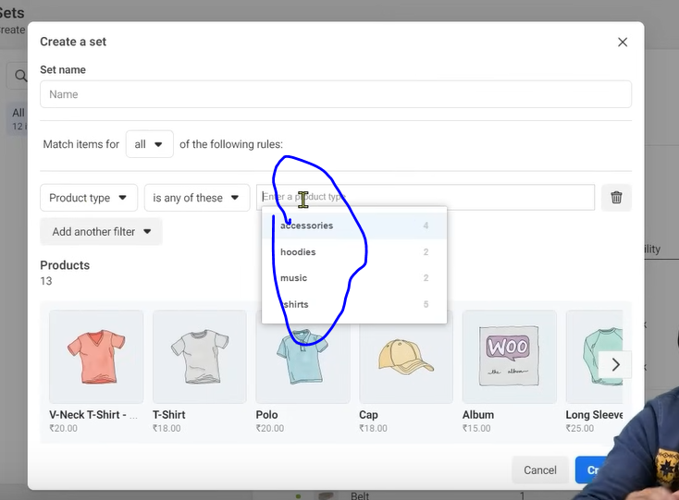

If you mentioned some parameter in your feed thn it will be shown in product details. So while story is that you should define the feed in a better way if you want to filter your products in a beter way

Now if you want ot create manually

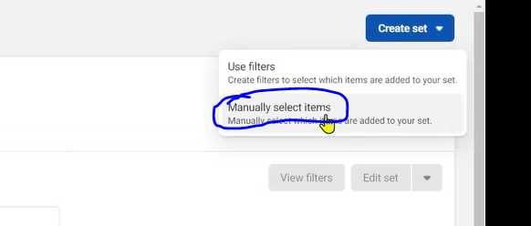

Click on the marked above to select products manually

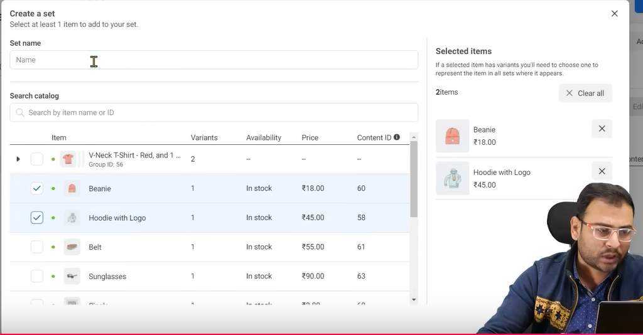

Now as shown above a window will be opened choose the product you want in your new product set and in Set name field set the name of the product set you want to make.

Click on button related to create the products set

Now we can run catalog ads on the basis of product we choose manually

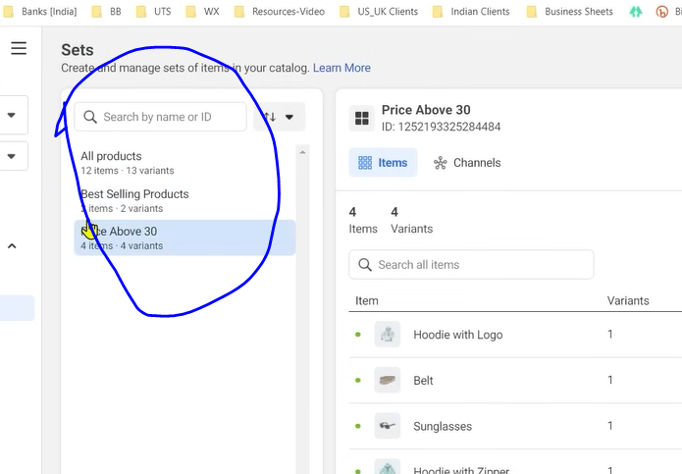

Now in sets list you can see All Products, Best Selling Products, Price above 30 product set is shown

Whenever we try to run ads then it will ask us that you want to run ads for all the products sets or you want to run specific product set

There it will give you option to create Product set but you have to assume on first hand thst It is mandatory to have a product set . If you cannot do it then you will not reach the right pople with right product

If you don’t know what categories can come in feed then you can go to the documentation below

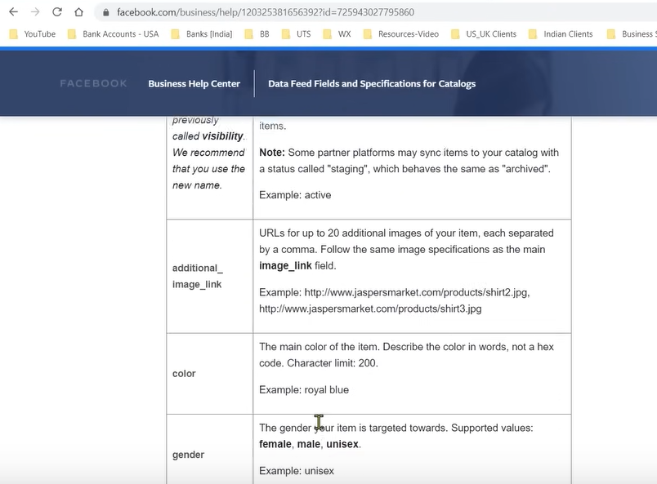

Some of the category is pattern

In this every shirt has some pattern in there texture .Now on the basis of pattern we can add filter example of pattern is like stripes. There is another category that is color.How we show product set then there should be data. How we make a product set there should be data

Some data go by default with the product that is product link

By first hand you should have a product set strategy

In next lesson we will se how to advertise the product in product set.

**Lesson 70:-**

In this lesson we will learn about **Catalogue Sales campaign effectively**

We will see how to run catalog based ads The ecosystem needed to set up we have already seen it.

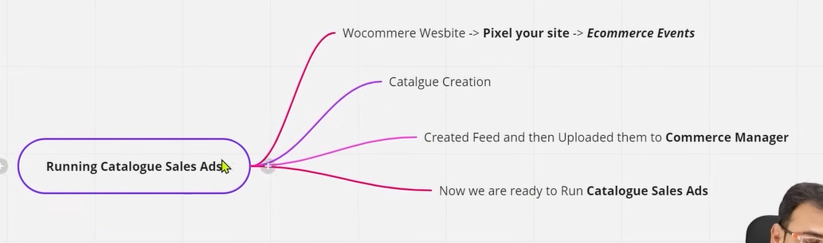

I think catalog is not visible in modern UI so we will see some from Teachedr perspective or some from ours

NOw here in campaign creation window we choose catalog campaign

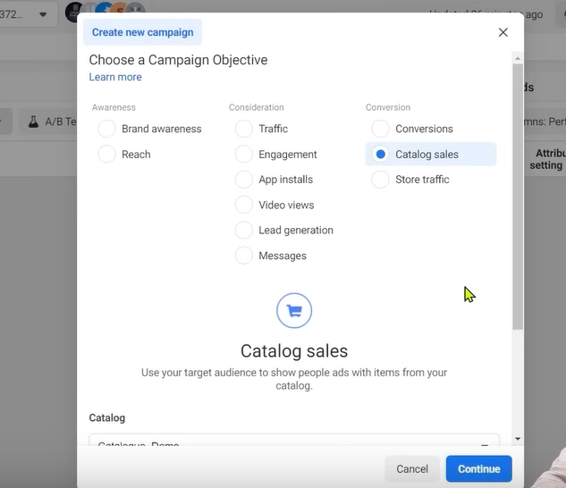

And now below it choose the catalogue as shoen below

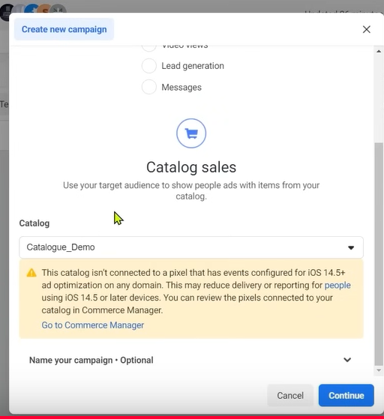

If you have multiple catloag hten they will be shown in in th submenu

As we know thw catalog contains products and the pixel contains the id of the prodduc that was visited

Now we need to connect our catalog to our pixel that’ what we are being notified in the yellow notification above so that the pixel can do tracking in a better way and can do optimization

Now to do it go your commerce manager and then to event in the side menu

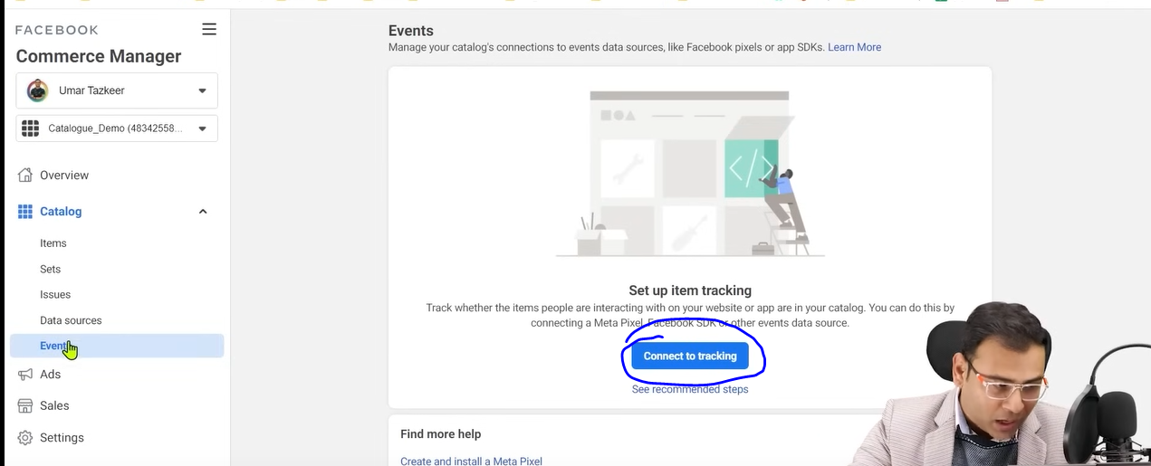

And now click on Connect to tracking button as shown above

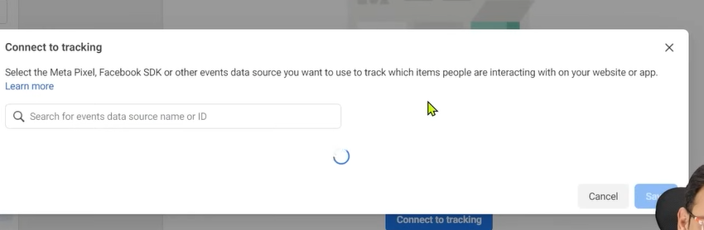

Andnnow in new window you will be shown the list of pixel and then connect it

And the yellow notification will be removed

You can name your campaign by clicking on the marked below

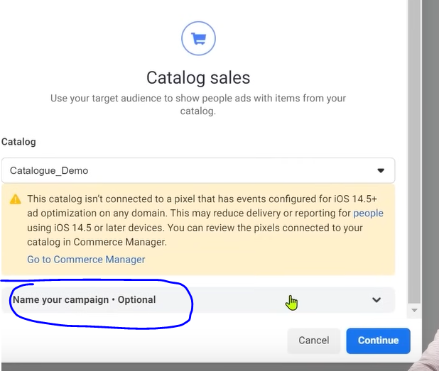

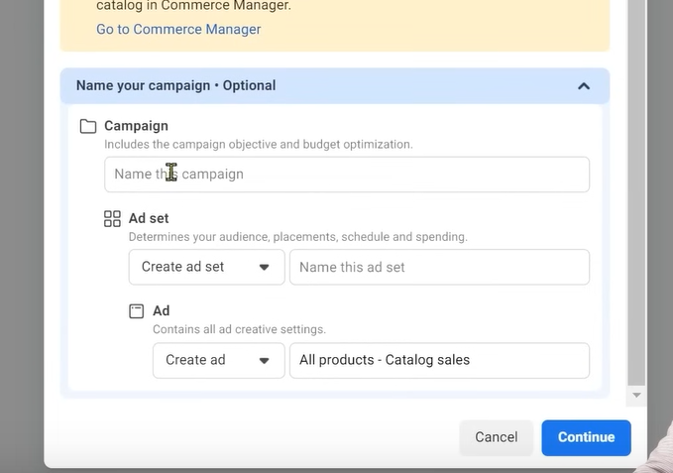Now click on Continue button

The yellow notification will not leave us it will be shown after we click on continue and when a new window is loaded

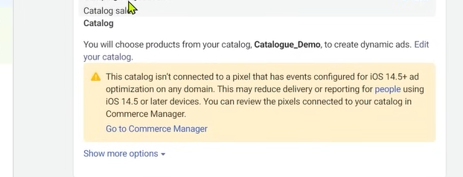

NOw enter the name of campaign as shown below

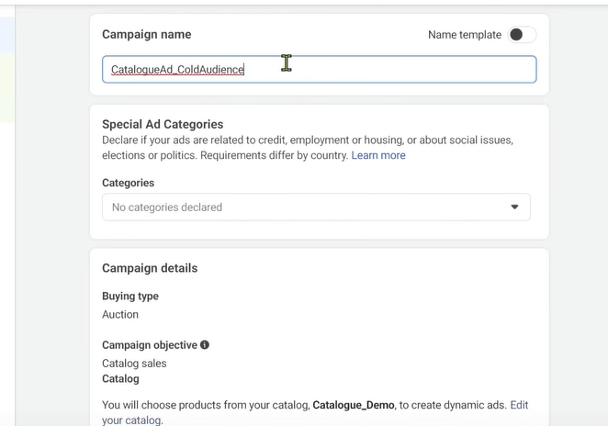

Now go to Ad set level

In adset you mostly target audience there

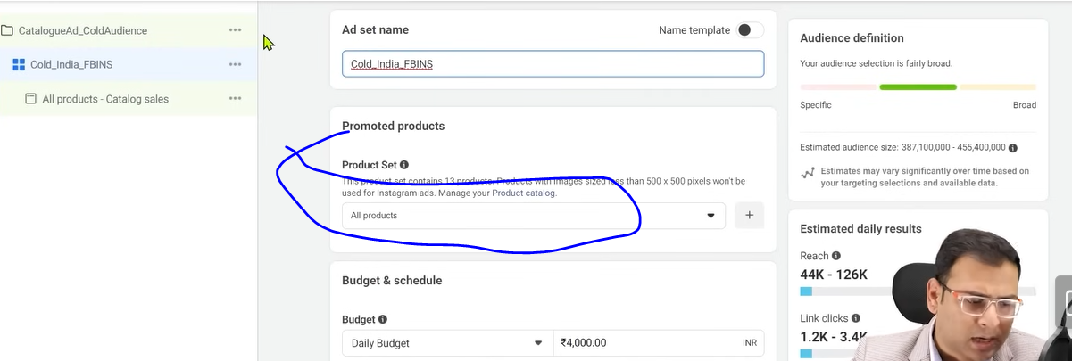

In above marked you se the option to choose the product set

You can see in above All products is choosed

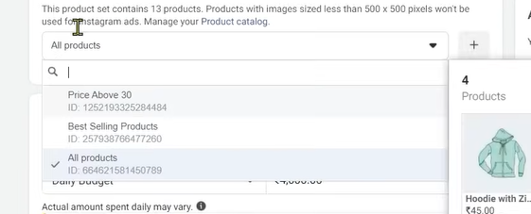

NOw whn you click on it you see the list of all product set you have made.

**Phase 95**

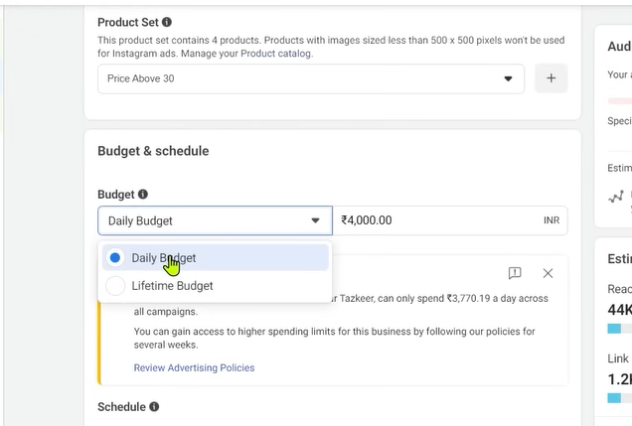

We choose Product set Price above 30

It will give you two option to choose audience one is Cold audience and Remarketing audience

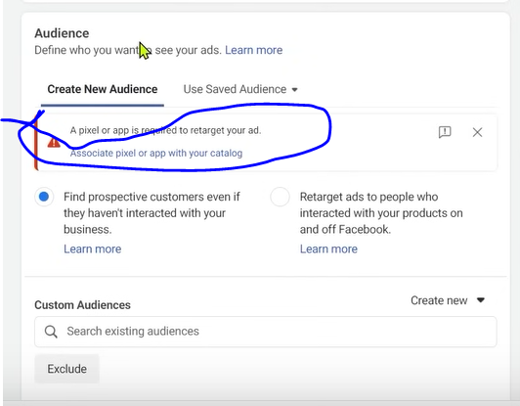

This is the advantages that you get whn you link catalog and pixeks then you can use this potential

You can see the same error related to connection between catalog and pixel maybe above as marked above.

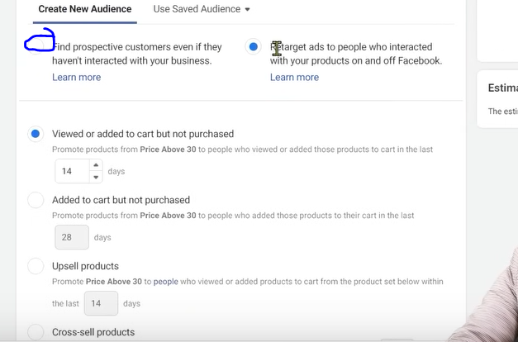

First marked checkbox is for the cold audience it will show the same interface for the targeting of audience as you have seen

Now if you click second checkbox

Here you get different criteria to create audience

You can see the option of Viewed or added to cart but not purchased

We can also target added to cart button purchased

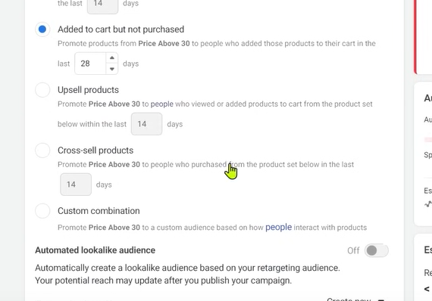

By Upsell products we mean whoever interacted with older products or other products

now you want to advertise ti tem our selected product set

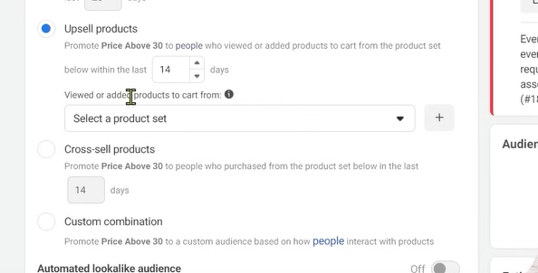

Now in Upsell products we can chose the product set as shown above.

Now if you chose a product set and then whoever interact with any product inside that product set then the ad related to ad set chosen previously will be shown to them

You choose option of Cross Sell products

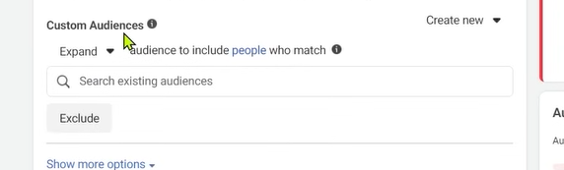

You can also target the audience which relate to the audience property we chosen for targetingin above

Then we go to placement and teacher usually

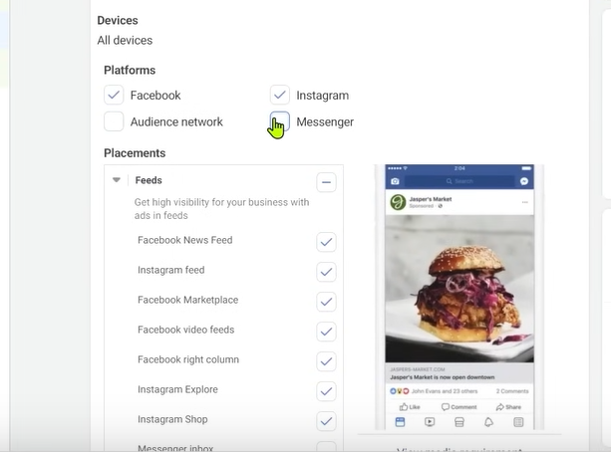

Deselect the Audiecnce Network, Messenger etc. because he want his ad to be shown in feeds

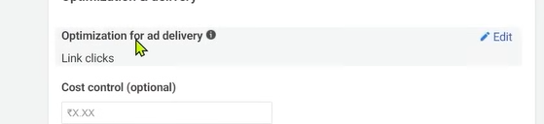

Now in optimization for ad delivery



If you are targeting cold audience then link click is good

But if you are retargeting or there is many convergence has come in your ad account. By convergence we mean in your event manager or pixel if your are seeing that there are many convergence event

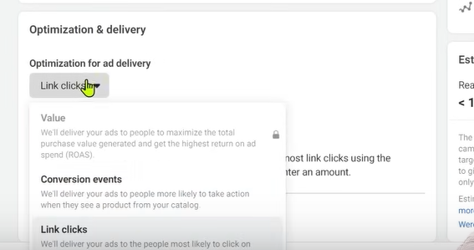

Then you choose conversion events

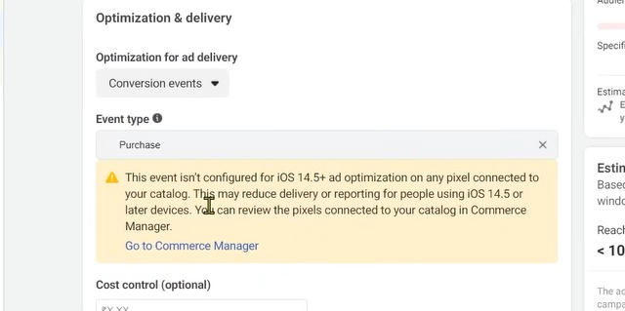

You can see in event typewe have chosen and it is showing eror becaue we have not linked catalog and pixel I think so

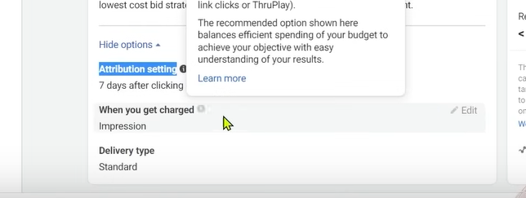

You keep the above thing as it is.

Now we will go to ad level and hre we will see the products which were I catalog How will they be show in the ad

Now we don’t need to add your product image as they will be added from the catalog we chosen tha’s why we make catalog so that we don’t have to add it separately

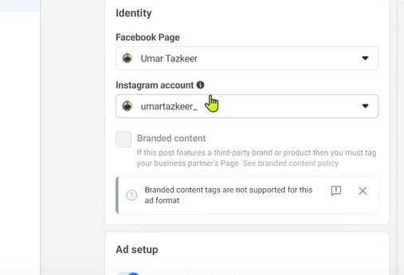

NOw if you want to promote it in INstagram then you can choose your instagram account

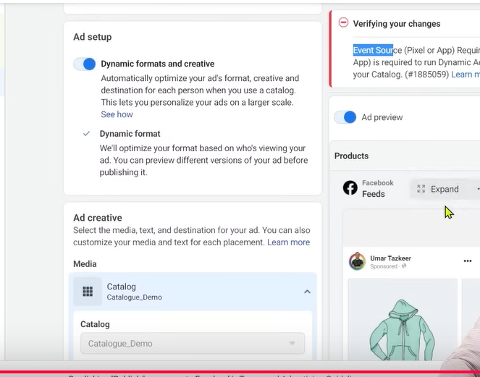

We will chose the Dynamic formats and creative so that our ad will be shown according to the user mean if facebook think that by showing particular products we can get convergence

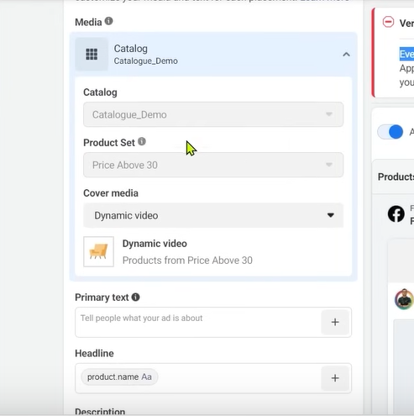

Images will be coming from catalog , Product set is already chosen

In cover media we have chosen. Dynamic video because in some placement the iver media is shown because we have keep other things dynamic

Then we have primary text

You can mention offers primary text.

By this it help to increase our CPR

In headline we are using dynamic element as shown above in greybox inside headlines

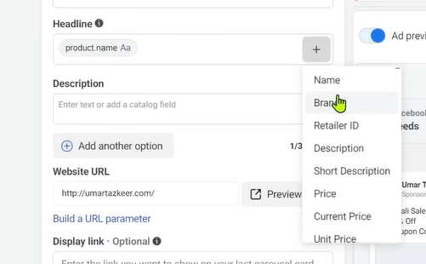

To add more dynamic elements click on + button and then in submenu choose the dynamic element you want whether Name,Brand etc.

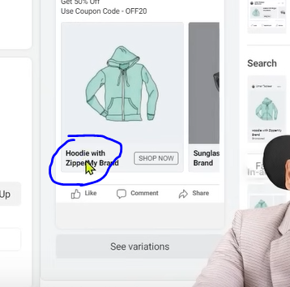

Now you can see the Product anme and brand as marked above in the ad.

Similarly we can do for Price

This is the advantage of catalog now you don’t need to enter anything manually here you can do so automatically by catalog

Now we have description

Teacher recommends that you call to action should be Shop Now

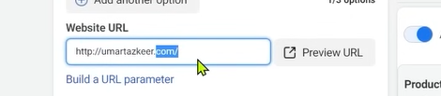

In website url chose you have to mention url which will take the user to your website home pge

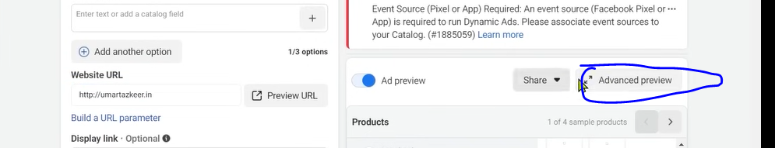

You can preview your ad by clicking on Advanced preview button

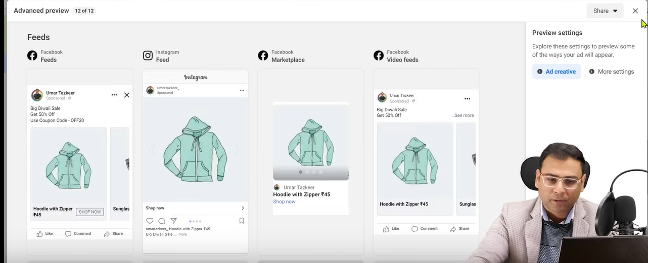

You can see the preciew above

Or you can share it by clicking on share button

Nnow a submenu will be opened

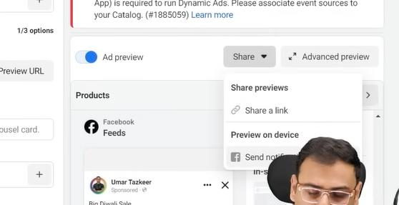

Click on Send notification then a notification will come in your mobile that will show your ad preview

In share a link you can share the preview to the client

In preview you check that after clicking on ad whether it is taking you to the url you mentioned

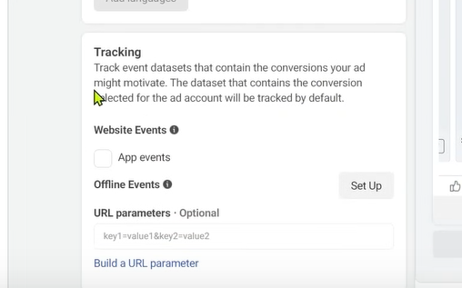

Hen your pixel get connected then you can choose the piel and then it will show you in traffic (who knows )

Now you can publish it.

The major thing that you need to understand is that you get the option to target cold audience or retarget audience on the basis of different parameters , conditions

An second thing to keep in mind that you keep the element dynamic in headlines , primary key and you keep the product set optimized it should not be like that different category product come in single product set then you may face challenges in optimization

If you have done all the things and you are using dynamic elements in your headlines, priomary key. Then ther are high chances that you get better result

**Lesson 71:-**

In this lesson we will see **How to customize catalog ads**

We will see if we want to customize the view of catalogue

In the previous lesson we talked about catalog sales ads.we saw how to do things dynamically

If we want to customize image shown in ad

For example if Repulic day sales is coming, republic day sales are coming , independence sales are coming or Diwali sales are coming and we want that our all product whatever we have

**Phase 96**

An Indian flag should be added to each of them as a frame or we wan that product pricing should be in the corner or offer price in corner

It is actually your ad creative if we want to do it then where doe we get the option from and how to do it.

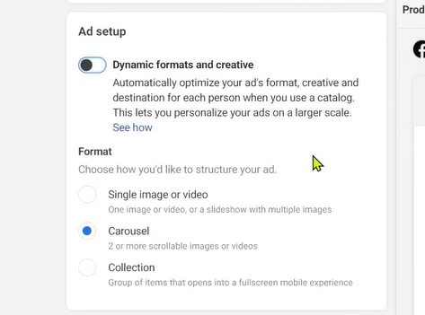

If in ad setup We turn the Dynamic formats and creative off and then you can see the three option below

You can choose the format below

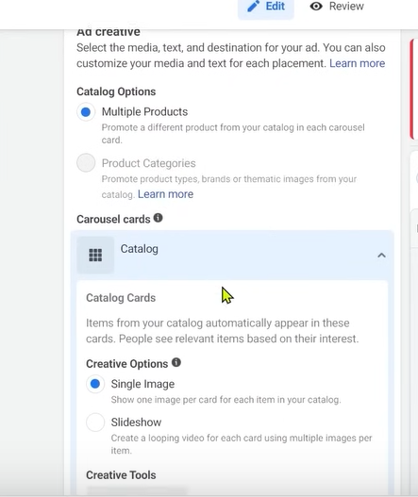

After this you have option as shown above that youi can bring some changes

In our ad creative Multiple projects are chosen.

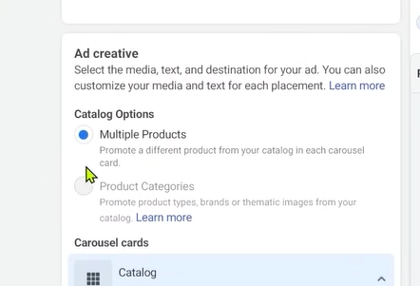

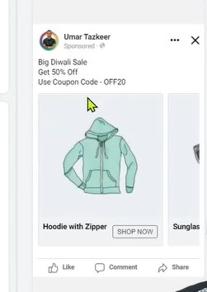

Now in our carousal a=card (slide where we see our product)

We want to customize that offer or price should be in corner then how to do it

For this in edit creative tools

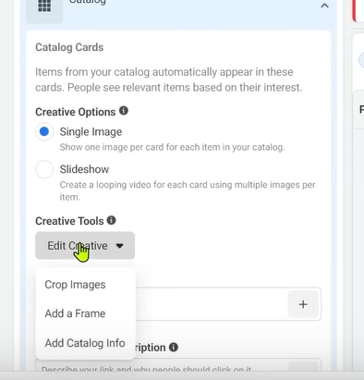

We get there option in Edit Creaive is that crop image, add a frame, Add catalog Info in the creative

First we see add a frame button so we click on it and then a window will be opened

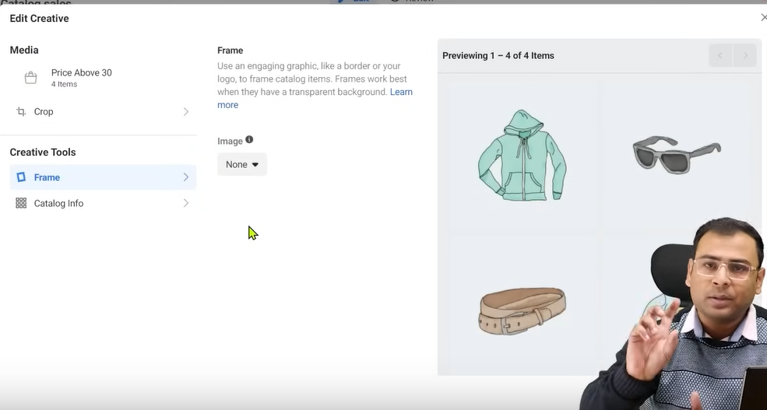

In frame we want something text written over the images like Diwlali sale, Republic day sale.You must see It in Amazon

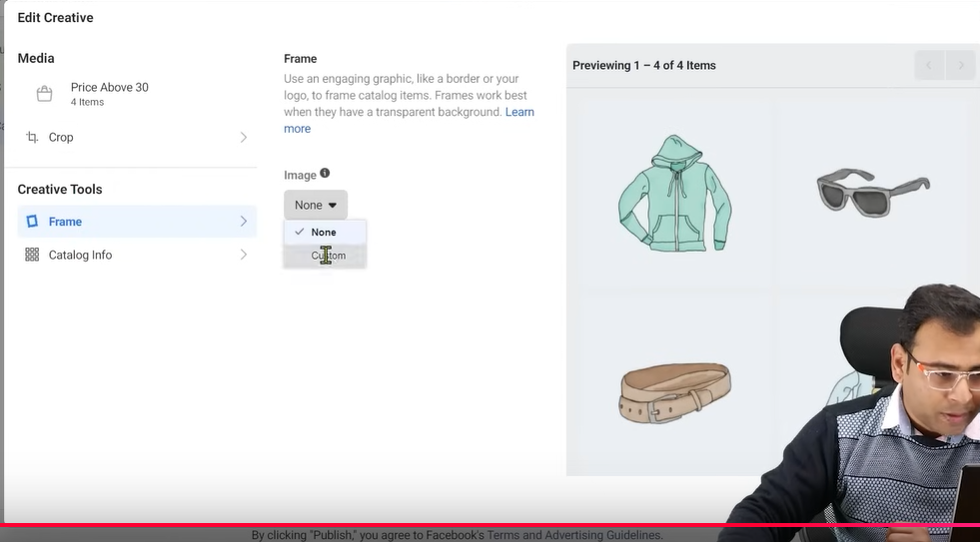

Now in frame we go to Image and then instead of none we choose custom as shown above

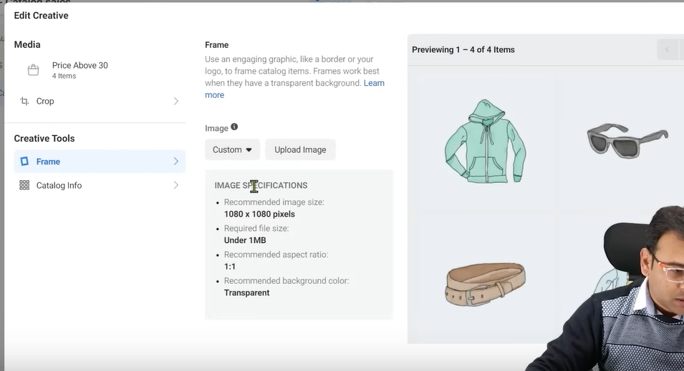

Now screen will be like above

Now we click on uload image to upload an image

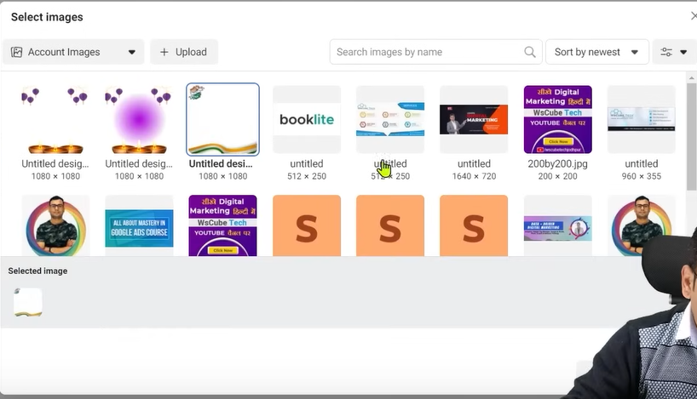

Teacher has lready chosen a frame so select any of them and upload it

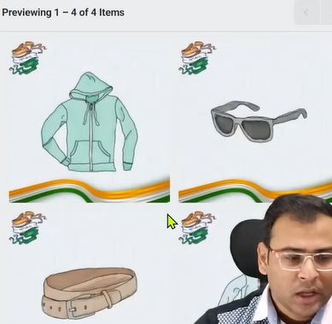

NOw you can see the frame

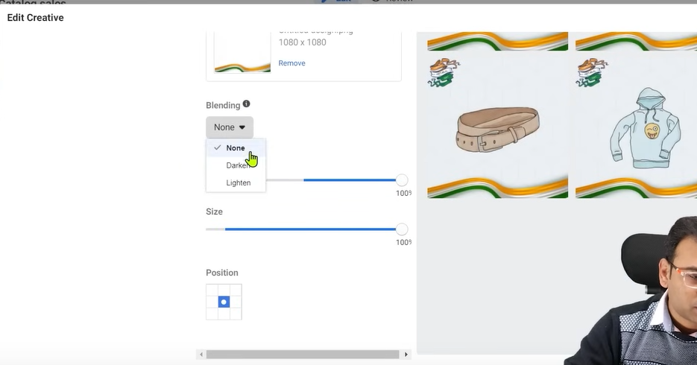

The Frame should be downloaded transparent means with transparent background

Now in above you can se the properties to customize the frame more.

In blending you can choose Darke or lighten

You can modify size, position and opacity as well

The frame can make you CPR better

It is seen that frame related to sales perform better and in sales campaign

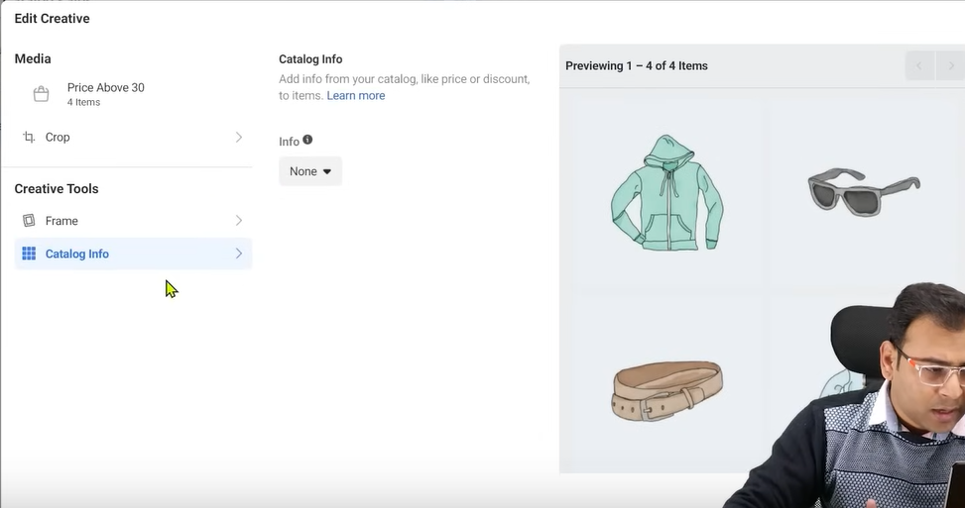

And now we go to catalogue info

Now therw are many information in our catalogue

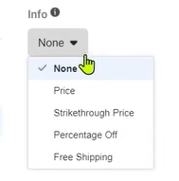

For example in info we have four option

Price,Strikethrough Price

Percentage Off

Free Shipping

If I click on free shipping then it will look like below

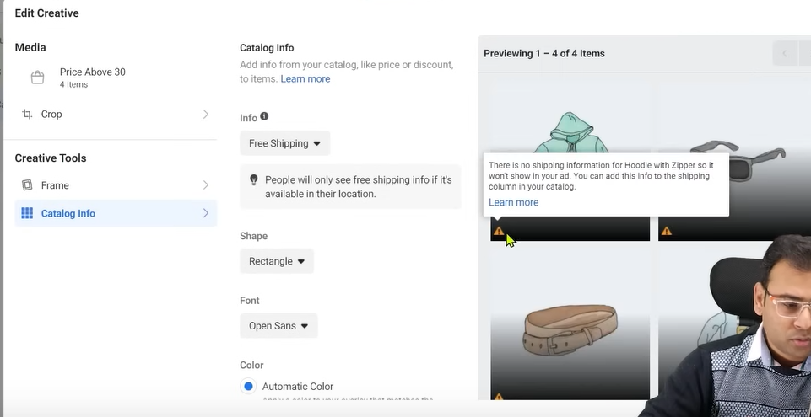

Since free shipping is not present in our catalog so it showing warning sign in each picture

But soce here is price parameter in catakog so we go to price

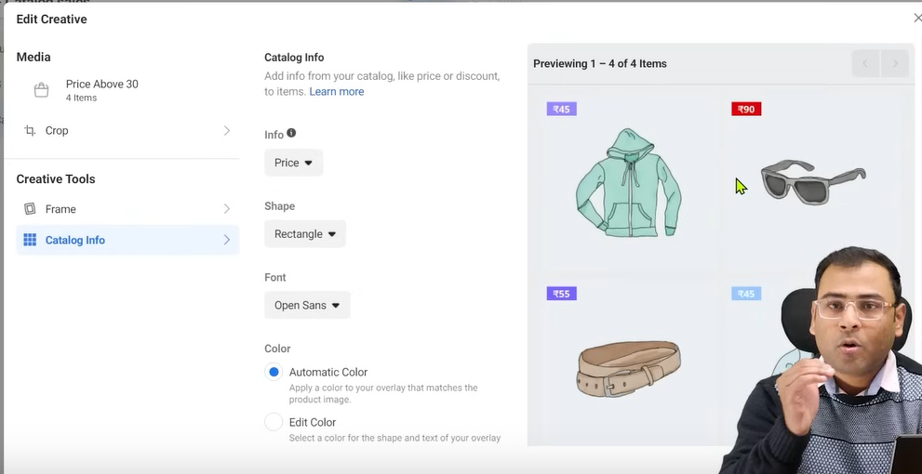

Now it is showing orice

If price is a factor in your case and you are doing very competitive price and my [pricing I good and by watching my pricing people will try to buy the product and they think it is cheap product or it is cost effective product and peole like that will buy it then you can do so

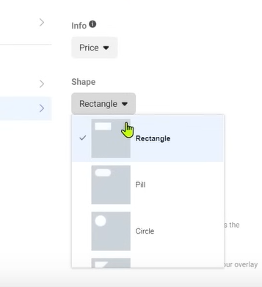

In shape we can choose shape of your catalog information

Our current is in rectangle and if we choose pill then it will look like below

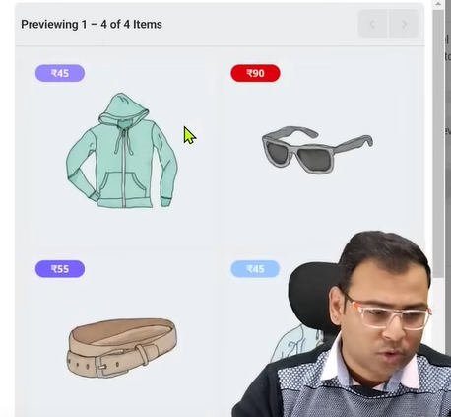

And if we choose circle then it will look like below

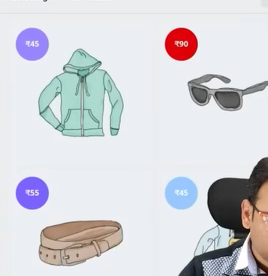

If we want to do so in triangle then it will look like below

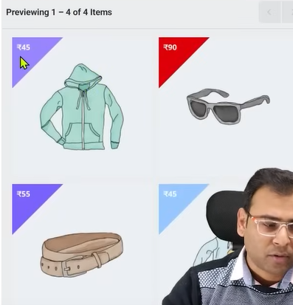

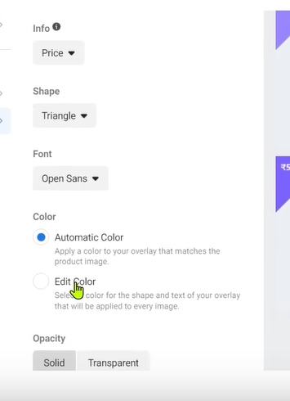

We can bring changes in our font

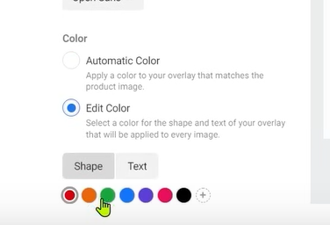

We can change its color and shape as well as shown below

If you choose edit color then you can do so but if you chose Automatic color then it will be decided by the algorithm

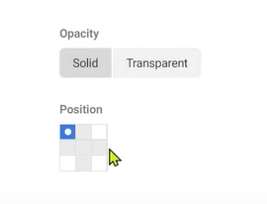

You can set its opacity whether keeping solid ir transparent and you can also set the position

But mostly top left position is chosen

Price will only work if you have mentioned it in your catalog info

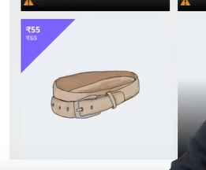

You can see th strike through 65 and 55 is our price after discount and you may have percentage discount and price in catalog info.

If we are for some s[pecific purpose we are runningour ad then and that purpose should be reflected in your ad creative so for that particular thing we can do all those things

They give you another option add card as shown below

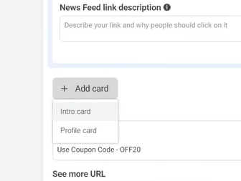

If you choose profile card then you can add your profile picture in your catalogue add end card

If if you want to dd a card as intro tehn you can choose Intro card

If you choose intro card

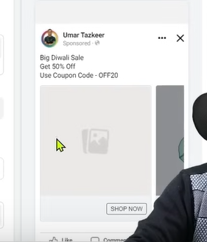

Then you can see intro card and tehn in next card you can see the product imges

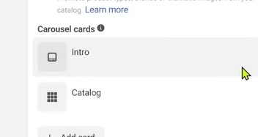

As you can see above there is intro card as shown above and then there is catalog

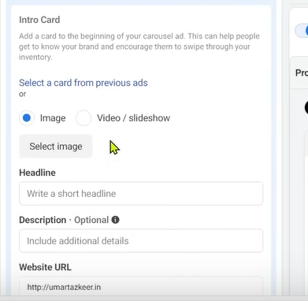

Now if we expand intro card then we can customize its feature like headline, Description, Webite url etc

You can select image for intro or do we want to keep url

And now if we add a profile card

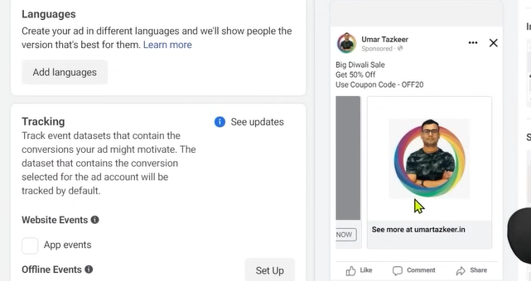

Now you can see in your products in your catalog ad in last there is profile picture

But it is not recommended if you want to run it for specific sales

You can add frame for specific purposes

It is recommended because that over the time you test the thing you never know that whether your audience will like your ad with ad or without frame or intro, profile card etc

But in the time of occasion frame will work

**Lesson 72:-**

In this lesson we will learn about **How to optimize product feed**

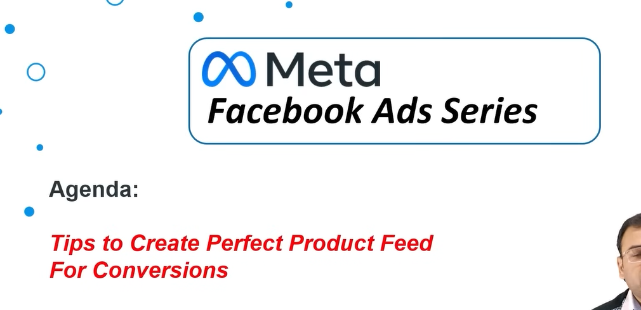

What we are saying is that whenever we ru ad for our ecommerce website we run our catalog website then we need product feed so we create it so do we need to keep thing sure while creating a feed

Is there specific rules for our parameter in our feed of each product that we should write title in a way and our description should be like this and our images should be like this we will discuss it It is very important concept

Only just creating a feed will not give you successful catalog ads

You have to understand that the information in your product feed or the best prcrtices you are following or not so teacher is going to give us some tips

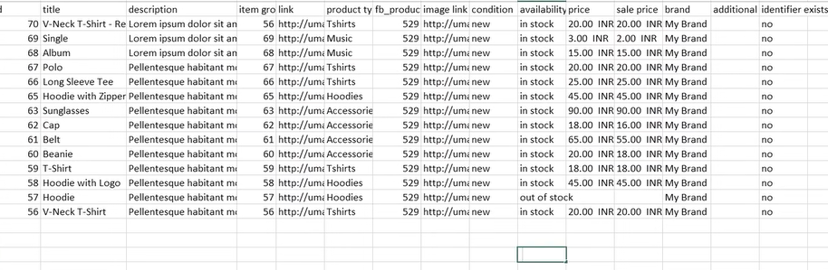

As we can see the product feed above there are many column

And different things how to write it and mention it so that we get better sales or facebook system will give you more convergence

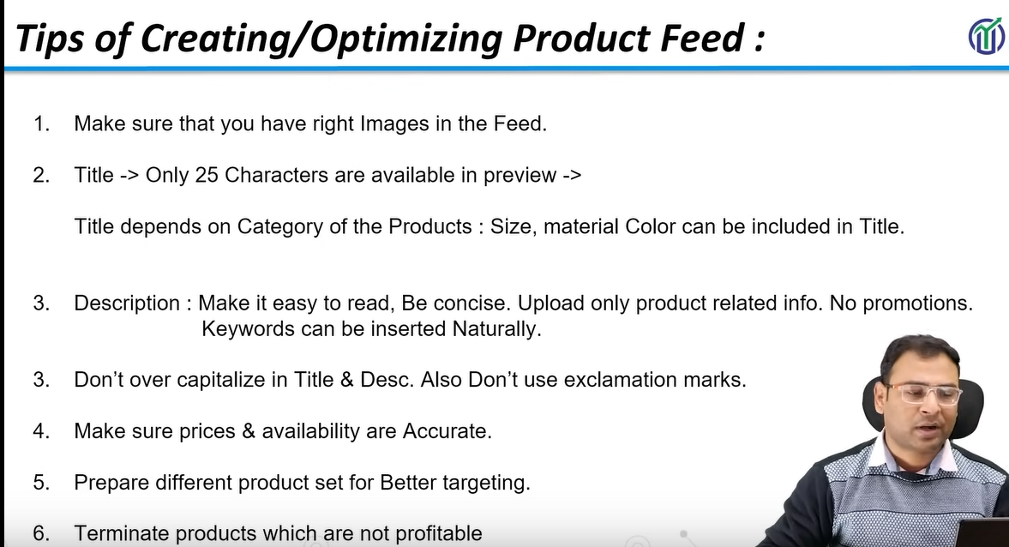

First point is that make sure that right images in our feed

Every product has an image link to image releated to that product

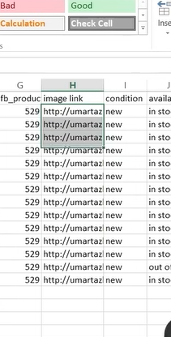

You image should be right it should not be like that in stead of primary image you see secondary image

For example if we talk about shoes now the image of front side of shoes is not there but of backside of the shoes basically that type of image is shown where the chances of convergence are very less.so we need to make sure that